

THE 6th VGIK INTERNATIONAL SUMMER SCHOOL

From Wikipedia, the free encyclopedia

Kaliningrad

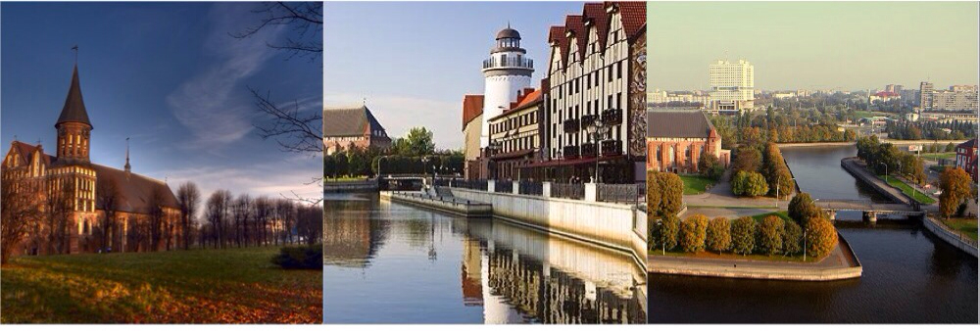

Kaliningrad (Russian: Калининград, German: Königsberg, Polish: Królewiec) is a seaport and the administrative center of Kaliningrad Oblast, the Russian exclave between Poland and Lithuania on the Baltic Sea. The territory borders on NATO and EU members Poland and Lithuania, and is geographically separated from the rest of Russia.

Originally named Königsberg, the Prussian and German town had been founded in 1255, and was then largely destroyed during World War II. Its ruins were occupied by the Soviet Army in 1945 and it was renamed Kaliningrad in 1946. In the meantime, the name was briefly Russified as Kyonigsberg (Кёнигсберг).

At the 2002 Census, its population was 430,003, an increase from the 401,280 recorded in the 1989 Census. Its ethnic composition is 77.9% Russians, 8.0% Belarusians, 7.3% Ukrainians, 1.9% Lithuanians[1], 0,6% Germans and 0,5 % Poles.

Geography

Kaliningrad is located at the mouth of the navigable Pregolya River, which empties into the Vistula Lagoon, an inlet of the Baltic Sea.

Sea vessels can access Gdańsk Bay and the Baltic Sea by way of the Vistula Lagoon and the Strait of Baltiysk.

Until circa 1900 ships drawing more than 2 meters (7 ft) of water could not pass the bar and come into town, so that larger vessels had to anchor at Pillau (now Baltiysk), where merchandise was moved onto smaller vessels. In 1901 a ship canal between Königsberg and Pillau was completed at a cost of 13 million marks, which enabled vessels of a 6.5 meters (21 ft) draught to moor alongside the town. (See also Ports of the Baltic Sea.)

Khrabrovo Airport is located 24 kilometers (15 mi) north of Kaliningrad, and has a few scheduled/charter services to several destinations throughout Europe. There is the smaller Kaliningrad Devau Airport for general aviation. Kaliningrad is also home to Kaliningrad Chkalovsk naval air base.

Climate

[hide] Weather averages for Kaliningrad
Month | Jan | Feb | Mar | Apr | May | Jun | Jul | Aug | Sep | Oct | Nov | Dec | Year
Record high °C (°F) | 12.7  (55) | 15.6  (60) | 23.0  (73) | 31.7  (89) | 30.6  (87) | 33.5  (92) | 36.3  (97) | 36.5  (98) | 31.2  (88) | 26.4  (80) | 19.4  (67) | 13.3  (56) | 36.5  (98)
Average high °C (°F) | -0.3  (31) | 0.1  (32) | 4.5  (40) | 11.1  (52) | 17.2  (63) | 20.6  (69) | 22.1  (72) | 21.7  (71) | 17.4  (63) | 11.9  (53) | 5.5  (42) | 1.9  (35) | 11.2  (52)
Average low °C (°F) | -5.4  (22) | -5.4  (22) | -2.3  (28) | 2.3  (36) | 6.8  (44) | 10.7  (51) | 13.0  (55) | 12.5  (55) | 9.2  (49) | 5.1  (41) | 1.0  (34) | -2.6  (27) | 3.8  (39)
Record low °C (°F) | -32.5  (-27) | -33.3  (-28) | -21.7  (-7) | -5.4  (22) | -3.1  (26) | 0.7  (33) | 4.5  (40) | 1.6  (35) | -2.0  (28) | -11.2  (12) | -18.7  (-2) | -25.6  (-14) | -33.3  (-28)
Precipitation mm (inches) | 57  (2.24) | 40  (1.57) | 43  (1.69) | 37  (1.46) | 53  (2.09) | 71  (2.8) | 80  (3.15) | 90  (3.54) | 89  (3.5) | 79  (3.11) | 91  (3.58) | 73  (2.87) | 803  (31.61)

Cityscape

Museums

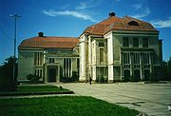
Museum of History and Arts (former city hall)

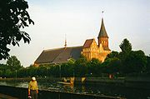
The Königsberg Cathedral

Kaliningrad has many museums. A few examples are the Immanuel Kant museum on the Kneiphof island, the Museum of History and Arts, which still has parts of the so-called Prussia collection of local archaeological findings, and the Kaliningrad Amber Museum, which is situated in the Dohna tower near the Rossgarten Gate. The city also has an art gallery with eight exhibition rooms.

The Museum of the World's Oceans is located on the former research vessel Wityaz on the shore of the Pregel river. The museum displays the newest technologies on sea research and also shows the diversity of the flora and fauna of the world's oceans. An anchored submarine next to the museum hosts an exhibit about the Russian submarine fleet.

Theatre

The Kaliningrad Philharmonic Orchestra is accommodated in the former Catholic Church of the Holy Family of Königsberg, built in 1907. The church was destroyed during World War II, but rebuilt afterwards. The building, which has noted acoustics, functions as an organ hall since re-opening in 1980.

The city's theater still located in the former Königsberg theater, which was opened in 1910. The building was rebuilt after the war using earlier plans for the theater and opened in 1960. The colonnade in front af the entrance was modeled after the Bolshoi Theatre in Moscow.

The regionally famous Kaliningrad puppet theater has its seat since 1975 in the Queen Louise Remembrance Church. This neoromatic church, designed by architect Fritz Heitmann, was built in 1901.

Architecture

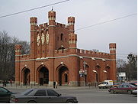
King's Gate

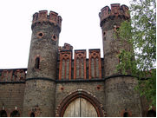
Gate of the Friedrichsburg Castle

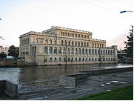
The former Königsberg Stock Exchange

The pre-war city centre (Altstadt and Kneiphof) currently consists of parks, broad avenues, a square on the site of the former Königsberg Castle, and only two buildings: the House of the Soviets ("Dom Sovyetov"), roughly on the site of the former Castle, and the restored Königsberg Cathedral on the Kneiphof island (now "Kant island"). Immanuel Kant's grave is situated next to the Cathedral. The new city centre is concentrated around Victory Square. The Cathedral of Christ the Saviour, consecrated in 2005, is located on that square.

Also worth seeing are the former Stock Exchange, the surviving churches, and the remaining city gates. In anti-clockwise order these gates are: the Sackheim Gate (German: Sackheimer Tor), King's Gate (German: Königstor), Rossgarten Gate (German: Rossgärter Tor), Attack Gate (German: Ausfallstor), Railway Gate (German: Eisenbahntor), Brandenburg Gate (German: Brandenburger Tor), and Friedland Gate (German: Friedländer Tor). Apart from the already mentioned Dohna tower, which houses the Amber museum, the Wranger tower also remains as a reminder of the former Königsberg city walls. Only the gate of the former Friedrichsburg Castle remains.

Monuments

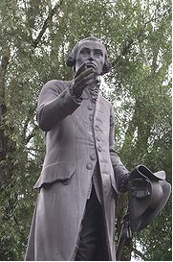
The Kant statue.

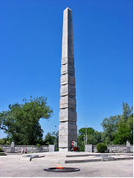
Monument for the 1200 Guardsmen.

Worth visiting monuments include the statue of Immanuel Kant in front of the Immanuel Kant State University of Russia. The statue was made by famous sculptor Christian Daniel Rauch and unveiled in 1864. The statue was destroyed in 1945, but was remolded in 1992 on the initiative of Marion Dönhoff. Also worth seeing is the Cosmonaut monument, which honors the Kaliningrad cosmonauts Alexei Leonov, Yuri Romanenko and Alexander Viktorenko. Other statues and monuments include the statue for count Albrecht, the statue for Friedrich Schiller, the statue for tsar Peter the Great, the "Mother Russia" monument, and the Monument for the 1200 Guardsmen, remembering the Battle of Königsberg.

Svetlogorsk, Kaliningrad Oblast

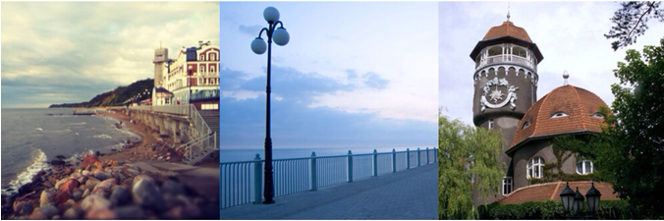

Svetlogorsk, prior to 1945 known by its German name Rauschen (Russian: Светлого́рск) is a town on the coast of the Baltic Sea in Russia's Kaliningrad Oblast. It is situated on the Sambian Peninsula and is a popular coastal resort. Population: 10,950 (2002 Census).

History

Svetlogorsk is situated in the historical region Sambia of East Prussia. A Sambian fishermen settlement named Ruse-moter (translated as 'region of cellars') at the place of Svetlogorsk was first mentioned in 1258. The Teutonic Order that conquered the land gradually corrupted the name into Rause-moter, Raushe-moter, and finally Rauschen.

In the early 19th century, the place became fashionable among German vacationers. On June 24, 1820 it was officially recognized as a spa town. During his visit to Rauschen in 1840, King Frederick William IV of Prussia ordered the sea embankment to be prettified. The arrival of the Königsberg railway in 1900 boosted the resort's popularity. A cable railway and a racecourse were constructed in Rauschen before World War I. Carl Otto Nicolai and Thomas Mann were among the celebrities who stayed there.

In 1945 Rauschen was conquered by the Soviet Union after World War II. It became part of the Kaliningrad Oblast and in 1946 the town was renamed to Svetlogorsk. Today it is a moderately popular summer resort town thanks to its beachfront and many spas, clubs and attractions.

Transport

Svetlogorsk is connected with Kaliningrad, Zelenogradsk, and Pionersky by electrified railway (3000 V DC). Svetlogorsk has two railway stations: Svetlogorsk-1 and Svetlogorsk-2 (terminus).
There are many private companies that operate buses between Svetlogorsk and Kaliningrad.

RUSSIAN STATE UNIVERSITY OF CINEMATOGRAPHY named after S. A. Gerasimov (VGIK)
W. Pieck str. 3, Moscow, 129226-RU
International Contact: (499) 181 17 60; 181 26 80; Fax (499) 181 80 74;
E-mail: foreign_vgik@mail.ru

